Mission to Mars: A Scavenger Hunt!

Hello, explorers!

Here’s your mission: Scientists want to study Mars, so you’ll need to send a robotic explorer, or rover, there to collect information. This might sound impossible, but you can definitely do it – NASA has sent four rovers to Mars and a fifth is on its way right now!

For the mission, you’ll need to learn all about Mars and how to get there. Once you collect each answer, enter it in the numbered spot on the next page. You’ll notice the letters in each shaded square will spell out a secret word – and when you get the secret word, you’re finished with the mission!

Learn about Mars. What will you want to study there?
Visit this All About Mars page: https://spaceplace.nasa.gov/all-about-mars
- What is the surface of Mars like?
(5 letters. Hint: You’ll find plenty of stones and pebbles.)
- Mars has ______, but they no longer erupt.
(8 letters. Hint: They aren’t active, so the floor is NOT lava.)

Preparing for Mars: What is it like there?
Visit this page to learn about the weather on other planets: https://spaceplace.nasa.gov/weather-on-other-planets
- The weather on Mars is _______ than the weather on Earth.
(6 letters. Hint: You’ll need lots of sweaters and blankets!)

Visit this page to learn about water on Mars: https://spaceplace.nasa.gov/mars-adventure2
- At the north and south pole of Mars, you can find ____ caps, just like on Earth! (3 letters. Hint: Brrrr! It’s cold at the poles!)

Launching to Mars: How will you get there?
Visit this page to learn about how rockets are used to launch things into space: https://spaceplace.nasa.gov/launching-into-space
- Gravity is a force that pulls things toward Earth. Rockets launch because they can create an upward force called _______, that overcomes gravity. (6 letters. Hint: The rocket creates this force by burning a fuel, called propellant.)

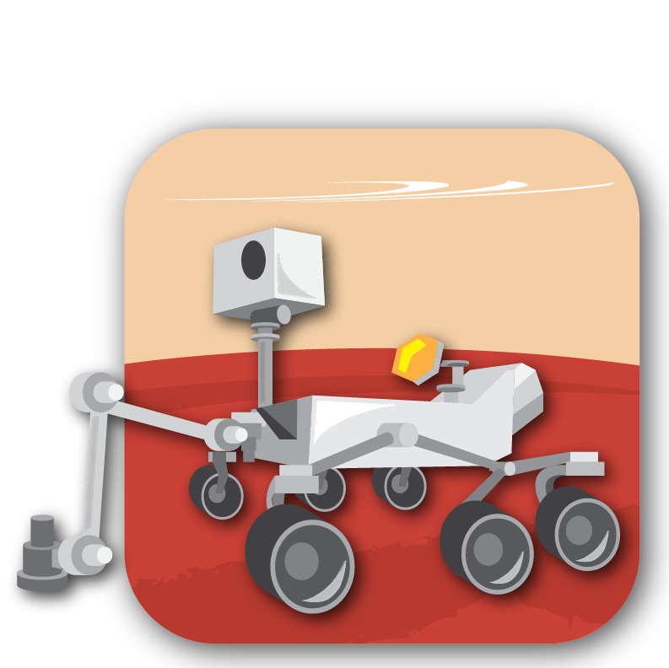
Driving on Mars: How will you tell the rover where to go?
Check out this page to play the Explore Mars game to learn how to drive the rover: https://spaceplace.nasa.gov/explore-mars
- You can drive the rover by sending it a sequence of ________.
(8 letters. Hint: You’re telling the rover what to do!)

Mission to Mars: A Scavenger Hunt!

Print this page and use a pen to write your answer next to the matching answer number.

Answer 1
Answer 3
Answer 2
Answer 4
Answer 5
Answer 6

SECRET WORD:

